THE DISAPPEARING MAGIC WAND
Your contact Info Here

Supplies needed:

- Several copies of the other side of this sheet.
- Scotch tape
- A No.2 pencil
- A pair of scissors
- A sheet of newspaper
- A grown up to help you

Making the Wand:

- Make sure you make copies of the other side of this sheet before you begin.
- Cut you paper along the dotted lines so that it looks like figure 1.
- Second, turn the paper black-side down.
- Begin rolling the paper around a No.2 pencil; roll it length-wise (fig. 2)
- Once the entire paper is rolled into the shape of a wand, loosen the tension enough to make the wand about ½” in diameter.
- Next, using a strip of scotch tape that is the same length as the black part of the wand, tape the wand in place (fig 3).
- Remove the pencil.

Performing the Magic:

- Show the audience the newspaper on both sides.
- Next, roll the wand up inside the newspaper much like you rolled the pencil inside of the paper wand.
- Make a magical pass over the paper; then tear it up.
- The wand will just get torn with the newspaper, and the audience will think that the wand disappeared.

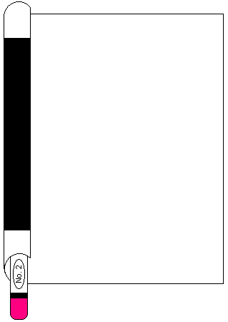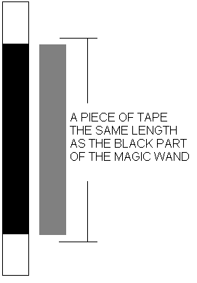
Figure 1 Figure 2 Figure 3

Parents: Download more free copies at your website here



